
PRESS RELEASE – 27th JANUARY, 2023
No.5A, Police Park Place, Colombo 00500, Sri Lanka
Tel & Fax: + 94 11 2055544
Email: reception@veriteresearch.org

MP Abeysinghe unrealistic on revenue estimates being unrealistic
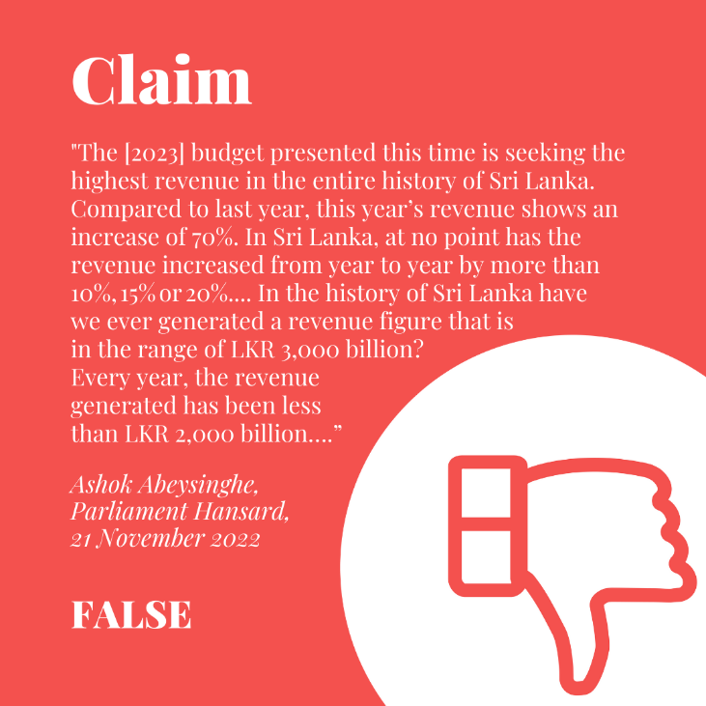
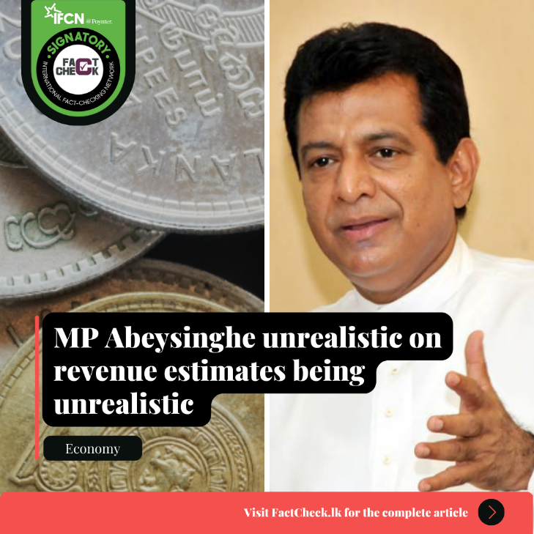

The MP makes two claims: (1) The 2023 budget estimate has a revenue increase of 70 % from 2022, while the increases have never been over 20% in the past. (2) This revenue estimate at over LKR 3,000 billion is the highest in Sri Lankan history, and that it has never been more than LKR 2,000 billion in the past. Through these claims, the MP is arguing that the revenue target for 2023 is unprecedented and unrealistic in terms of the percentage increase and the total forecasted revenue figures. To evaluate these claims, Factcheck.lk consulted the CBSL Annual Report for 2021, the 2023 budget speech.
Claim 1: The claim that this increase in revenue is unprecedented is incorrect. About 11 times since 1950, the nominal revenue has increased by more than the 20% maximum cited by the MP, with the highest percentage increase being 75% in 1978. The estimated revenue increase for 2023, from the revised revenue estimates for 2022, is 64% which is a little less than the 70% cited by the MP.
Claim 2: As claimed by the MP the expected revenue for 2023 is the highest nominal value on record, at LKR 3,408 billion. As claimed, nominal revenue has also never exceeded LKR 2,000 billion. Even though the numbers are correct, the derived argument is incorrect. It is normal for the revenue estimate in most budgets to be the highest on record because inflation and economic growth will result in an increase of the nominal value of revenue collected, even when revenue remains the same as a percentage of GDP. To evaluate in terms of what is sensible or achievable, the comparison would be the real value (inflation adjusted value) or in terms of the percentage of GDP. On those measures the 2023 estimate is not unprecedented or an excessively high or an unrealistic estimate. (For all the years in which the real value and the revenue as percentage of GDP is higher, see full version on FactCheck.lk).
The MP is wrong on the percentage increase of revenue being unprecedented and hugely misleading on the total value of revenue being unrealistic. Therefore, we classify the MP’s statement as FALSE.
*FactCheck.lk’s verdict is based on the most recent information that is publicly accessible. As with every fact check, if new information becomes available, FactCheck.lk will revisit the assessment.
FactCheck.lk is a platform run by Verité Research.
For more fact checks, visit our website at www.factcheck.lk.

No.5A, Police Park Place, Colombo 00500, Sri Lanka
Tel & Fax: + 94 11 2055544
Email: reception@veriteresearch.org

